ANS1. https://github.com/priyanshu599/SummerSchool2026.git

ANS2. 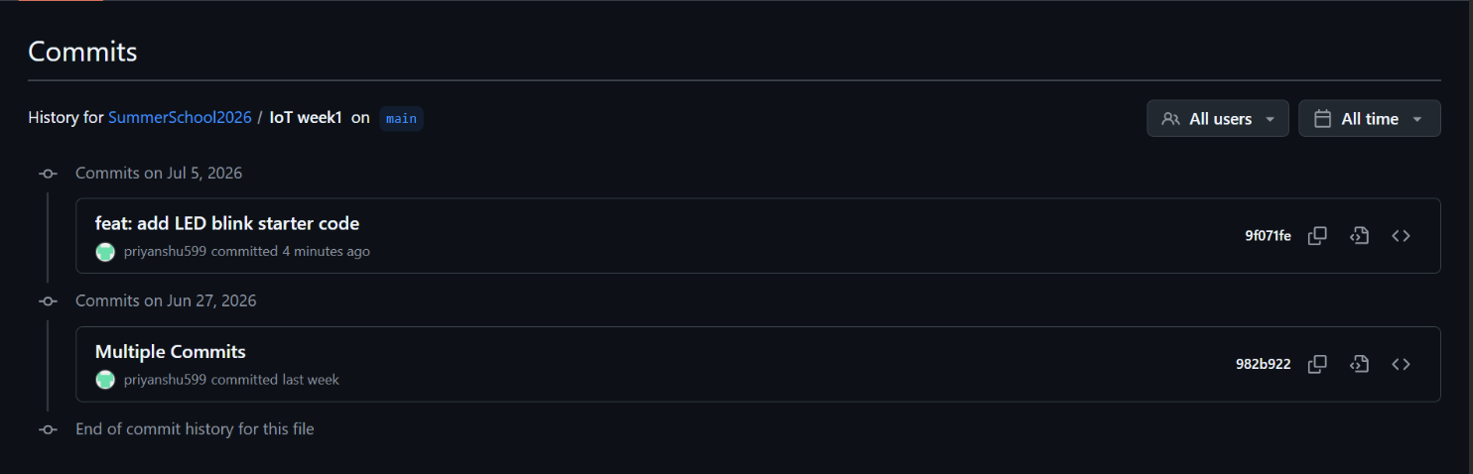

ANS3. https://github.com/priyanshu599/SummerSchool2026/commit/839bb40b88e56de65cb 8ede193f0cf77e6bb30b5

Section B: Practical Tasks (4 marks each)
ANS4.
I progressively improved the LED Blink project by creating four separate Git commits to demonstrate version control using Git.
Version History:
v1.0
- Implemented the basic LED Blink program.
- LED blinks every 500 ms.

v1.1
- Added Serial Monitor support.
- Displayed the blink count after each blink.

v1.2
- Connected a potentiometer to control the LED blinking speed.
- Used analogRead() and map() to vary the delay dynamically.

v1.3
- Added a professional comment header containing:
  - Author Name
  - Roll Number
  - Date
  - Project Description
Commit Messages: 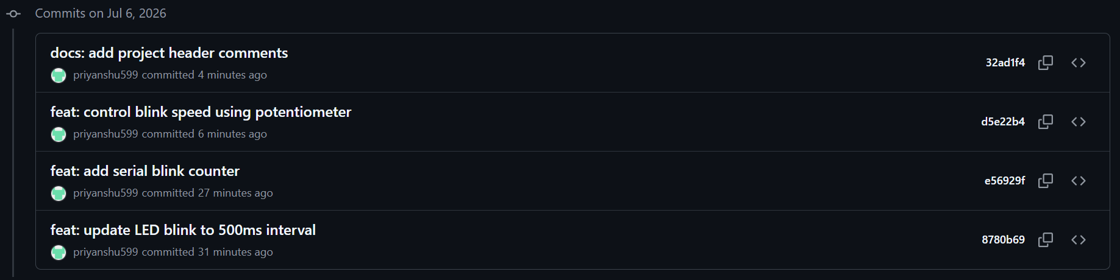
GitHub Repository
https://github.com/priyanshu599/SummerSchool2026/tree/main/IoT%20week1/led_blink

ANS5.
A professional README.md file was created for the LED Blink project. It includes:
- Project Title
- Project Overview
- Hardware Required
- Circuit Diagram Description
- Step-by-step code upload instructions
- Expected Output
- Troubleshooting Tips
- Author Details
The README helps users understand the project, hardware setup, and execution process, making the project easy to use and maintain.
GitHub Repository:
https://github.com/priyanshu599/SummerSchool2026/blob/main/IoT%20week1/led_blink/README.md

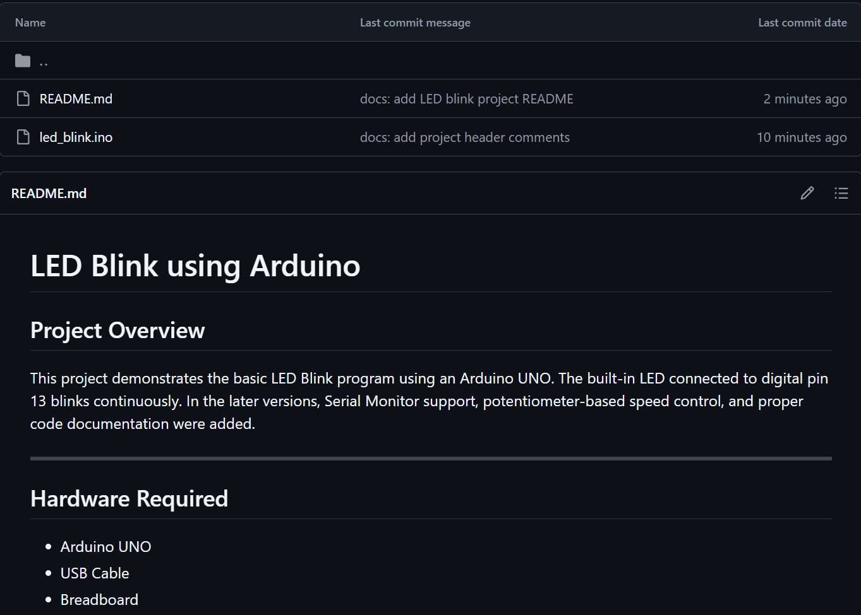

ANS6.
Three GitHub Issues were created to manage bugs and future improvements in the LED Blink project.
The following Issues were added:
- Bug: Blink interval not changing when potentiometer is at maximum.
- Feature: Add RGB LED support.
- Enhancement: Log Serial Monitor data in CSV format.
All issues were assigned to me and linked to the milestone Week 1 Completion.
One issue was automatically closed using a Git commit containing the keyword Fixes #IssueNumber.
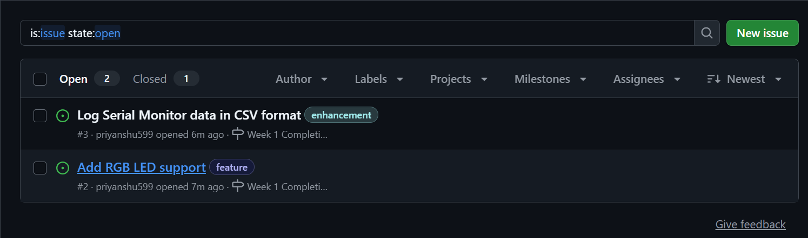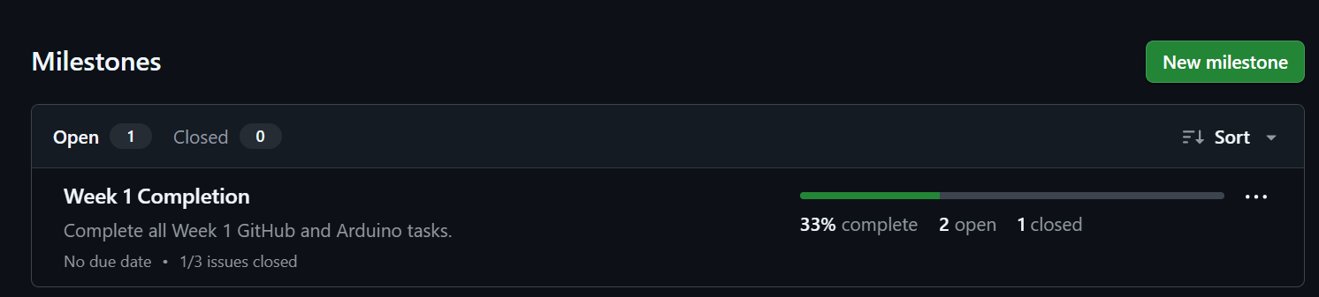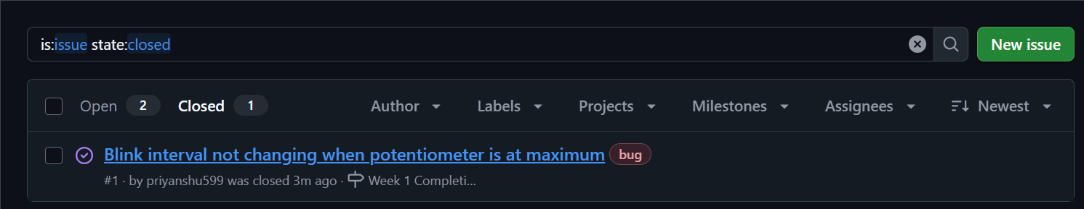

ANS7.
A partner's GitHub repository was forked successfully. A modified LED Blink program was added that blinks the LED three times rapidly and pauses for two seconds before repeating. The changes were committed, pushed, and submitted as a Pull Request for review. After review, the Pull Request was merged into the original repository.
Partner Repository:
https://github.com/ShivamYadav30/IoT_Summer_school_2026

Pull Request URL:
https://github.com/ShivamYadav30/IoT_Summer_school_2026/pull/4#issue-4814474562
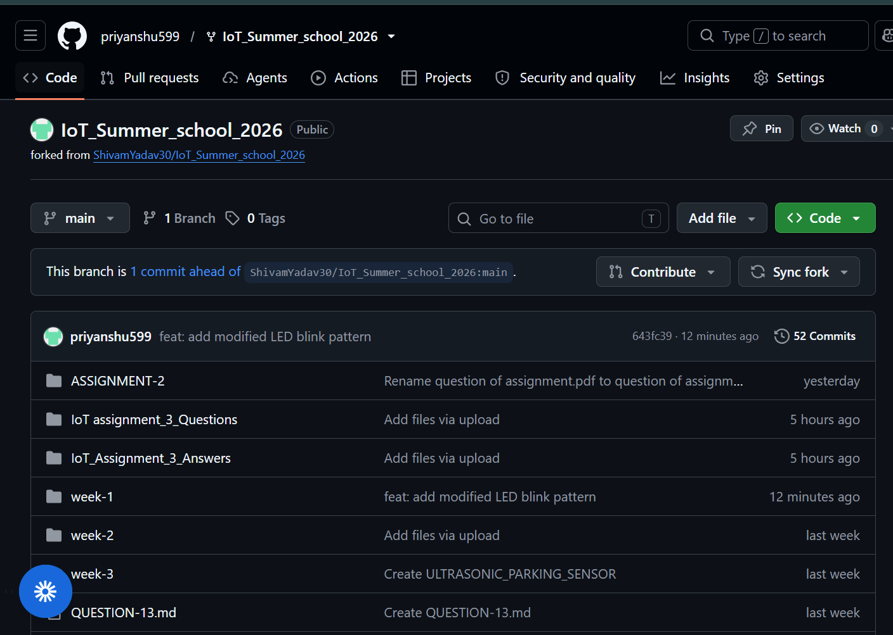
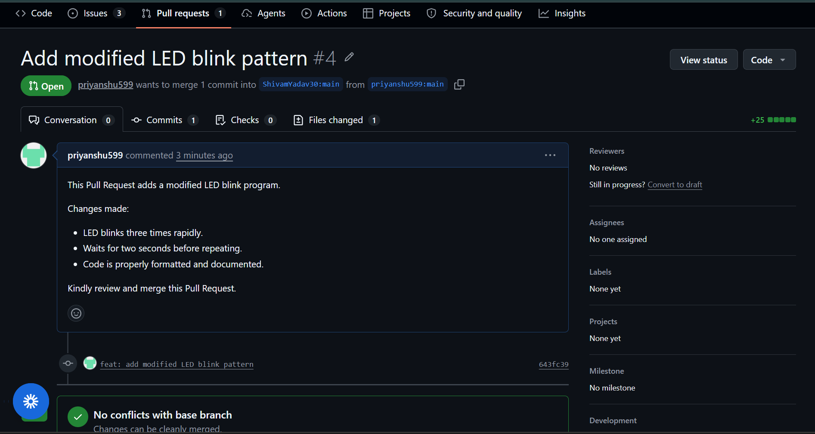

ANS8.
A GitHub Actions workflow was created to automate a simple Continuous Integration (CI) task. Whenever code is pushed to the repository, the workflow automatically runs a Python script that counts the number of Arduino (.ino) files and displays the count in the GitHub Actions log.
This demonstrates basic automation using GitHub Actions.
Workflow File:
https://github.com/priyanshu599/SummerSchool2026/tree/main/.github/workflows

Python Script:
https://github.com/priyanshu599/SummerSchool2026/tree/main/scripts
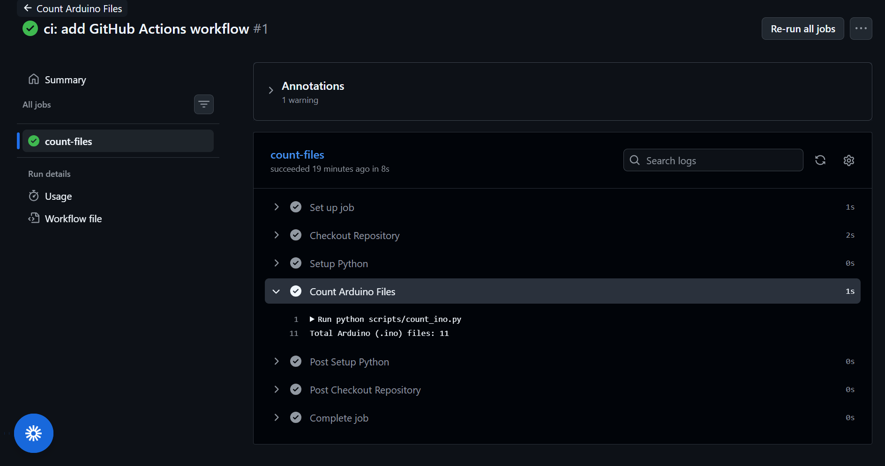

ANS9.
1. git clone
- git clone is used to copy an entire remote repository to your local computer.
- It downloads all files, branches, and commit history.
- It is mainly used when working on a repository for the first time.
Example:
git clone https://github.com/priyanshu599/SummerSchool2026.git
2. git fetch
- git fetch downloads the latest changes from the remote repository but does not merge them into the local branch.
- It allows you to review the changes before merging.
Example:
git fetch origin
3. git pull
- git pull downloads the latest changes from the remote repository and automatically merges them into the current local branch.
- It is commonly used to keep the local repository updated.
Example:
git pull origin main
When to Use Each
Command | Purpose | When to Use
git clone | Copies a repository to the local system | When working with a repository for the first time
git fetch | Downloads changes without merging | When you want to review updates before merging
git pull | Downloads and merges changes | When you want to update your local repository with the latest changes

ANS10.
A .gitignore file tells Git which files and folders should not be tracked or uploaded to the GitHub repository. It is useful for excluding temporary files, compiled files, build folders, and IDE configuration files that are not required in the project.
Using a .gitignore file keeps the repository clean, reduces unnecessary uploads, and prevents accidental sharing of unwanted files.
Sample .gitignore for an Arduino Project
# Compiled files
*.hex
*.elf
# Build folder
build/
# VS Code settings
.vscode/
# Operating System files
.DS_Store
Thumbs.db
# Temporary files
*.tmp
*.log
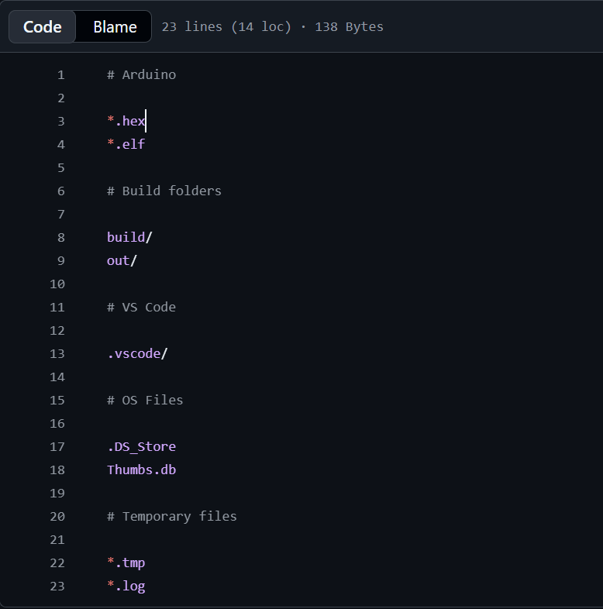

Module 2: IoT Fundamentals & Arduino Programming
Marks: 20 | Questions: Q11–Q20 | Type: Code + Explanation

📌 Hardware Required for This Module
- Arduino UNO / Nano / Mega (any one)
- LEDs (Red, Green, Blue), 220Ω resistors, Buzzer
- Push buttons, 10kΩ pull-down resistors
- Breadboard, jumper wires, USB cable

Section A: Conceptual Questions (2 marks each)
ANS11.
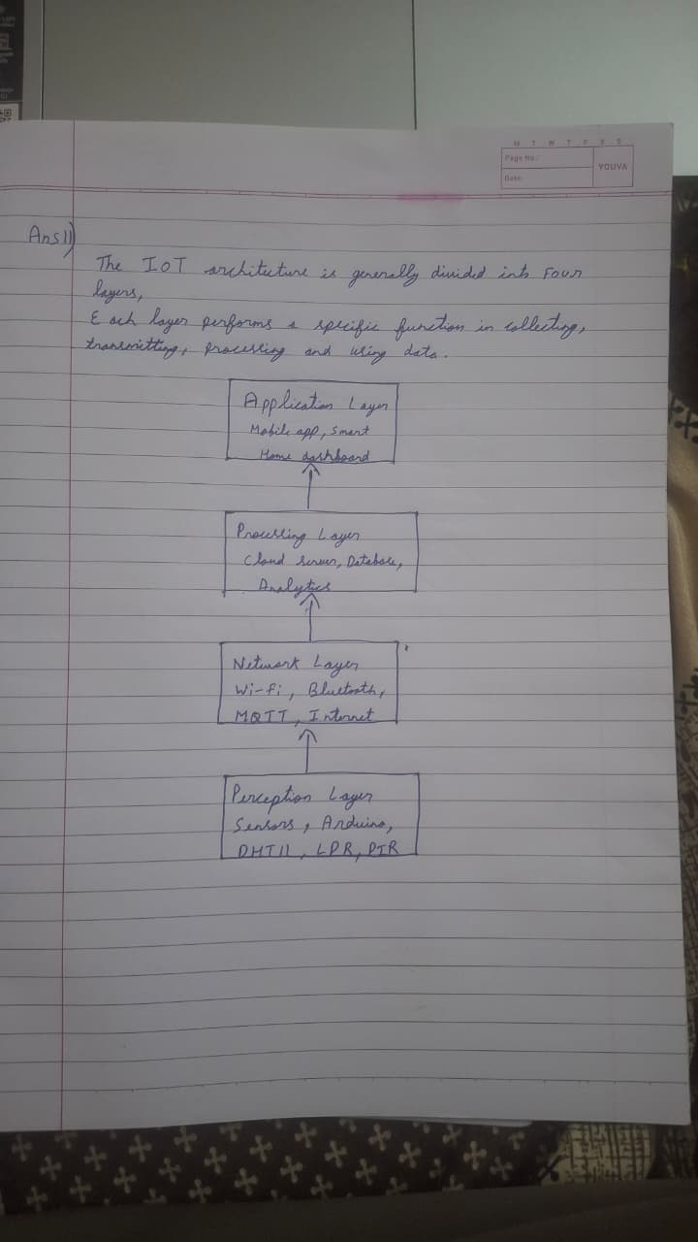
Examples of Each Layer:
- Perception Layer
  - Function: Collects data from the physical environment using sensors and devices.
  - Example: DHT11 temperature and humidity sensor.
- Network Layer
  - Function: Transfers data from sensors to servers or cloud platforms.
  - Example: Wi-Fi module (ESP32/ESP8266).
- Processing Layer
  - Function: Stores and processes the received data.
  - Example: Cloud database such as Firebase.
- Application Layer
  - Function: Provides services to the end user.
  - Example: Smart Home mobile application or weather monitoring dashboard.
Conclusion:
The Perception Layer senses the environment, the Network Layer sends the data, the Processing Layer analyzes and stores it, and the Application Layer presents useful information to the user.

ANS12.
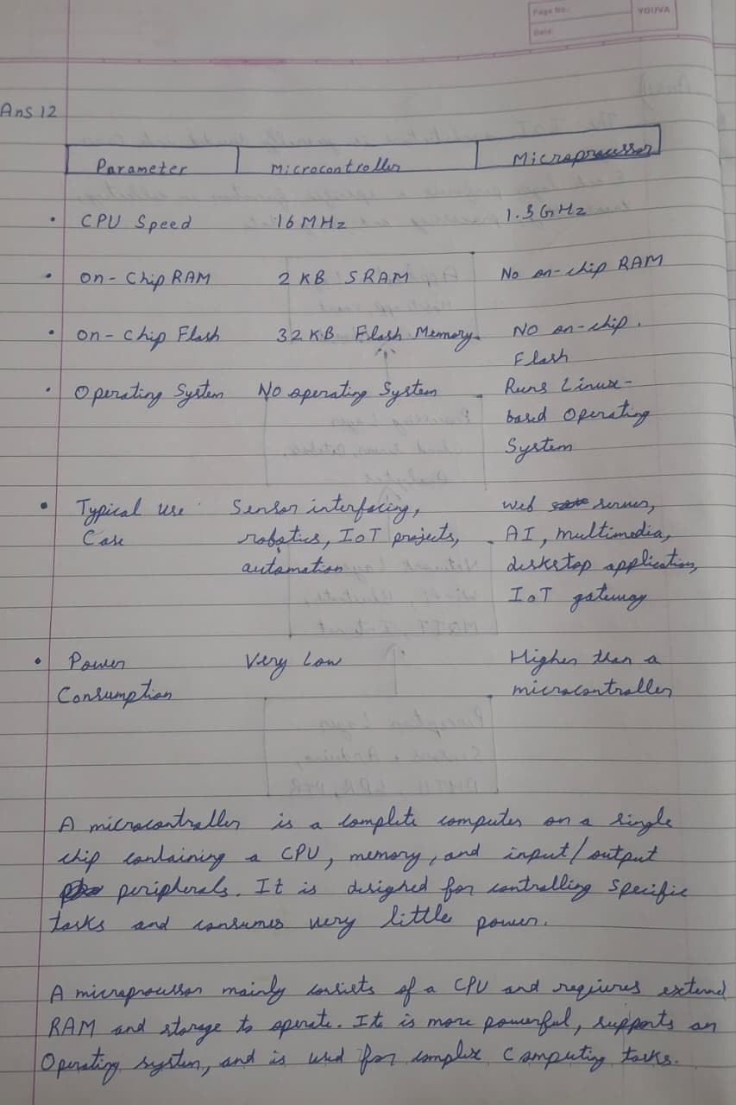

ANS13.
Arduino UNO has different types of pins that perform specific functions such as reading inputs, controlling outputs, communicating with sensors, and connecting with other devices.
Pin Type | Explanation | Example | Real IoT Use Case
Digital Input | Reads only two states: HIGH (1) or LOW (0). Used to receive signals from buttons and switches. | Push Button connected to pin 2 | Smart Door Lock where a push button unlocks the door.
Digital Output | Sends HIGH or LOW signals to control external devices. | LED connected to pin 13 | Smart Home system to turn an LED or relay ON/OFF.
Analog Input | Reads varying voltage values (0–5V) and converts them into digital values (0–1023). Available on pins A0–A5. | LDR or Potentiometer connected to A0 | Automatic Street Light using an LDR sensor.
PWM Output | Generates Pulse Width Modulation signals to simulate analog output. Available on pins 3, 5, 6, 9, 10, and 11. | LED brightness control on pin 9 | Fan Speed Controller or LED Brightness Control.
I2C / SPI Pins | Used for communication between Arduino and modules like displays and sensors. I2C uses SDA and SCL, while SPI uses MOSI, MISO, SCK, and SS. | OLED Display using I2C | Weather Monitoring System displaying sensor data on an OLED screen.

Common Arduino UNO Pin Numbers
Digital Pins
0 – 13
Used for LEDs, buttons, relays, buzzers, etc.
Analog Pins
A0 – A5
Used for LDR, potentiometer, temperature sensor, soil moisture sensor, etc.
PWM Pins
3, 5, 6, 9, 10, 11
Used for LED fading, motor speed control, and servo-related PWM applications.
I2C Pins
SDA → A4
SCL → A5
SPI Pins
MOSI → D11
MISO → D12
SCK → D13
SS → D10

Conclusion
Different pin types on the Arduino UNO allow it to interact with sensors, actuators, communication modules, and displays. Choosing the correct pin type is essential for building reliable IoT applications.

ANS14.
A traffic light controller was implemented using three LEDs and one push button. The traffic signal follows the sequence:
- Red LED ON for 5 seconds
- Yellow LED ON for 2 seconds
- Green LED ON for 4 seconds
When the pedestrian button connected to pin 7 is pressed, the controller immediately switches to the Red LED and keeps it ON for 8 seconds to allow pedestrians to cross safely.
The current traffic light state along with the timestamp obtained using the millis() function is displayed on the Serial Monitor.
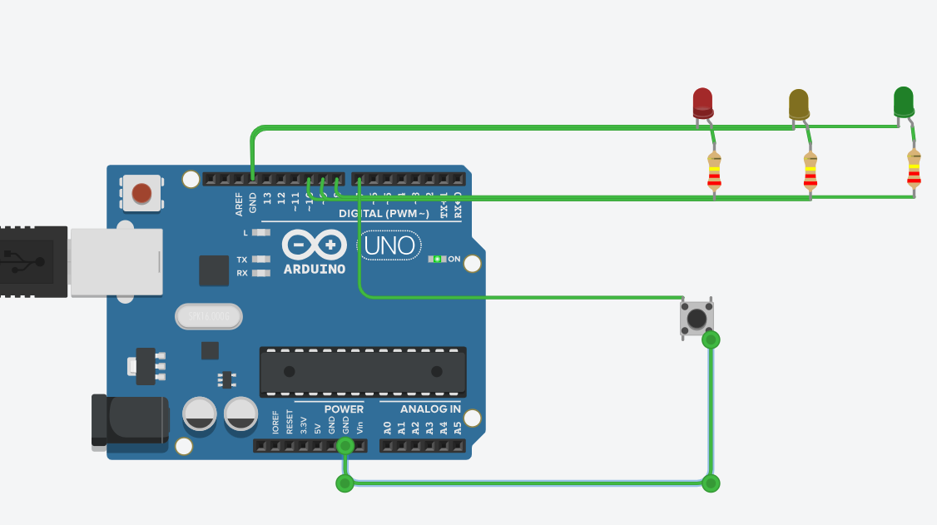
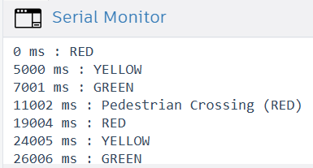

ANS15.
A digital piano was developed using four push buttons and a passive buzzer. Each button plays a musical note (Do, Re, Mi, and Fa). The buzzer stops when the button is released. If two buttons are pressed simultaneously, the system plays the Sol note (392 Hz) as a chord substitute. A fifth button is used to switch between Major and Minor scales, and the selected mode is displayed on the Serial Monitor.
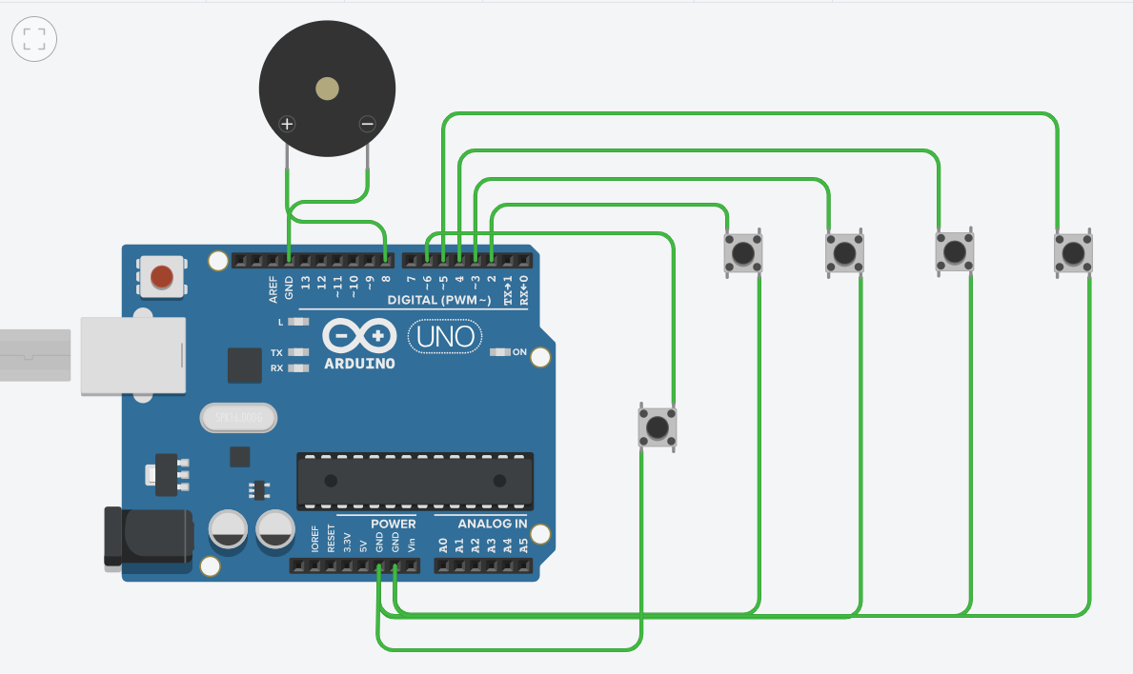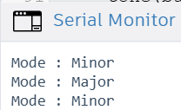

ANS16.
A Serial Command Interface was developed using the Arduino UNO. The program receives commands from the Serial Monitor and controls the built-in LED. It supports turning the LED ON/OFF, blinking the LED a specified number of times, displaying the current LED status and blink count, and resetting the blink counter. Invalid commands are detected and an appropriate error message is displayed.
Supported Commands:
- LED_ON
- LED_OFF
- BLINK_X (where X = 1–9)
- STATUS
- RESET
Unknown commands display:
ERROR: Unknown command

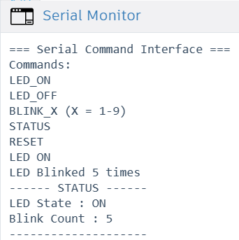

ANS17.
A PWM-based automatic night light was developed using an Arduino UNO. An LED connected to a PWM pin produces different lighting effects. A push button is used to switch between three operating modes:
- Slow Breathing (3-second cycle)
- Fast Pulse (0.5-second cycle)
- SOS Pattern (... --- ...)
The current mode is displayed on the Serial Monitor whenever the button is pressed.

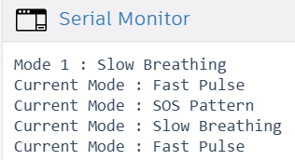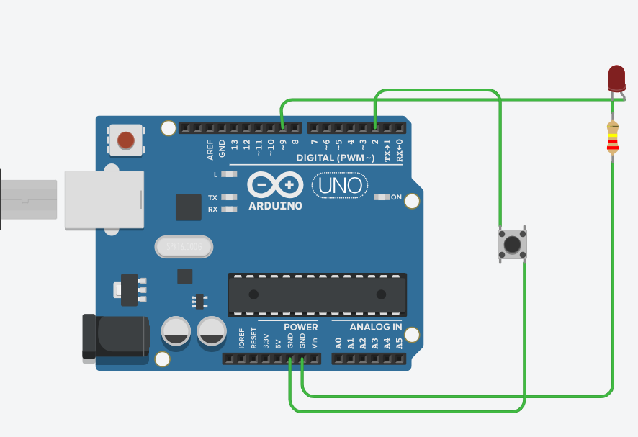

ANS18.
A vending machine was implemented using the Finite State Machine (FSM) concept. The system has four states: IDLE, COIN_INSERTED, ITEM_SELECTED, and DISPENSING. Three push buttons are used to insert a coin, select an item, and cancel the operation. Three LEDs indicate the current state of the vending machine, and every state transition is displayed on the Serial Monitor.
The code also includes a comment block documenting the state transition diagram as required.

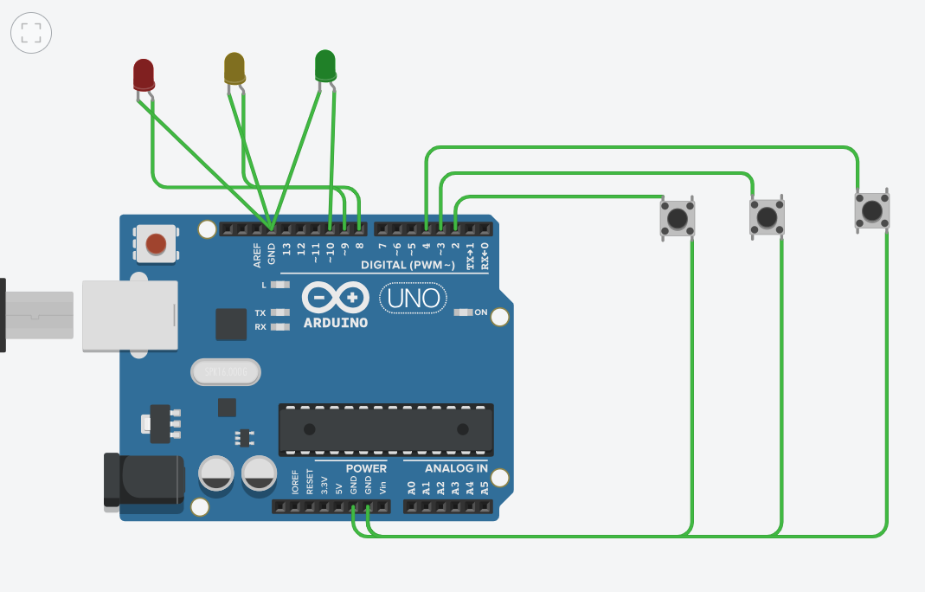
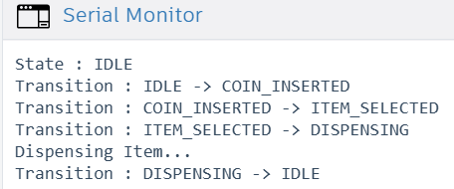

ANS19.
Difference between analogRead() and analogWrite()
analogRead() | analogWrite()
Reads analog voltage from a sensor. | Generates a PWM signal to simulate analog output.
Used with analog input pins (A0–A5 on Arduino UNO). | Used with PWM pins (3, 5, 6, 9, 10, 11 on Arduino UNO).
Returns a value between 0 and 1023. | Accepts a value between 0 and 255.
Used to read sensor values such as LDRs or potentiometers. | Used to control LED brightness, motor speed, and similar devices.
What is PWM?
PWM (Pulse Width Modulation) is a technique used to simulate an analog output by rapidly switching a digital pin ON and OFF. By changing the duty cycle, Arduino can control the average power supplied to a device.
Why is PWM Used?
PWM is used to:
- Control LED brightness.
- Control DC motor speed.
- Generate smooth fading effects.
- Reduce power consumption compared to keeping a device fully ON all the time.

Practical IoT Examples
analogRead()
Example: Smart Street Light
An LDR sensor is connected to an analog pin. Arduino reads the light intensity using analogRead() and automatically turns the street light ON at night.

analogWrite()
Example: Smart Home LED Brightness Control
Arduino uses analogWrite() to adjust LED brightness according to ambient light or user input from a mobile app.
Conclusion
analogRead() is used to receive analog sensor data, while analogWrite() uses PWM to control the output level of devices such as LEDs and motors. Together, they are commonly used in IoT projects for sensing and controlling hardware.

ANS20.
setup() Function
The setup() function runs only once when the Arduino is powered on or reset. It is used to initialize the board, configure pin modes, and start communication such as the Serial Monitor.
Example:
void setup() {
pinMode(13, OUTPUT);
Serial.begin(9600);
}

loop() Function
The loop() function runs continuously after setup() finishes. It contains the main program logic and keeps repeating as long as the Arduino is powered.
Example:
void loop() {
digitalWrite(13, HIGH);
delay(1000);
digitalWrite(13, LOW);
delay(1000);
}

When we use a long delay() is used inside loop() a long delay() stops the Arduino from performing any other task during that time. While the program is waiting:
- Sensor readings are delayed.
- Button presses may be missed.
- The system responds slowly to external events.
For example, if delay(5000) is used, the Arduino will not check a sensor or button for 5 seconds.

Effect on Sensor Reading Responsiveness
Using long delays reduces the responsiveness of the system. If a sensor detects an important event during the delay period, the Arduino may not read it until the delay finishes. This can cause missed detections or slow responses in IoT applications.

Non-Blocking Alternative
A better approach is to use the millis() function. It keeps track of elapsed time without stopping the program, allowing the Arduino to perform multiple tasks such as reading sensors, checking buttons, and controlling LEDs at the same time.
This technique is called non-blocking programming and is widely used in IoT systems for better performance and responsiveness.
Conclusion
- setup() runs once to initialize the Arduino.
- loop() runs continuously to execute the main program.
- Long delay() calls reduce responsiveness by blocking the program.
- Using millis() is the preferred non-blocking method for handling multiple tasks efficiently.

Module 3: Sensors, Actuators & Data Acquisition
Marks: 20 | Questions: Q21–Q30 | Type: Hands-On Experiments

🔬 Sensors Covered in This Module
- DHT11/DHT22 – Temperature & Humidity
- HC-SR04 – Ultrasonic Distance
- LDR – Light Dependent Resistor
- PIR – Passive Infrared Motion Sensor
- Soil Moisture Sensor, MQ-2 Gas Sensor (optional)

Section A: Sensor Experiments (4 marks each)

ANS21.
An Environmental Monitoring Station was developed using an Arduino UNO and a DHT22 sensor. The system reads temperature in both Celsius and Fahrenheit, along with humidity, every 2 seconds. The readings are displayed on the Serial Monitor in CSV format. A Red LED turns ON when the temperature exceeds 35°C or humidity exceeds 80%; otherwise, a Green LED remains ON. Five sample readings were saved in a CSV file and uploaded to the GitHub repository. 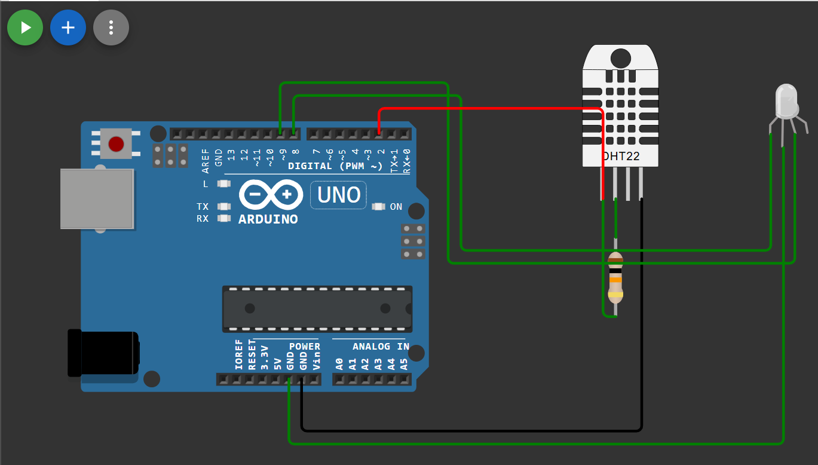
ANS22.
An ultrasonic parking sensor system was developed using the HC-SR04 ultrasonic sensor and Arduino UNO. The distance is calculated using the formula:
distance = (duration × 0.034) / 2
The system works as follows:
- Distance > 50 cm: Green LED ON and Serial Monitor displays SAFE.
- Distance 20–50 cm: Yellow LED ON and the buzzer beeps every 500 ms.
- Distance 10–20 cm: Red LED ON and the buzzer beeps every 200 ms.
- Distance < 10 cm: All LEDs flash rapidly and the buzzer remains continuously ON.
The project uses the millis() function for non-blocking timing, allowing the Arduino to continue measuring distance while controlling the LEDs and buzzer.

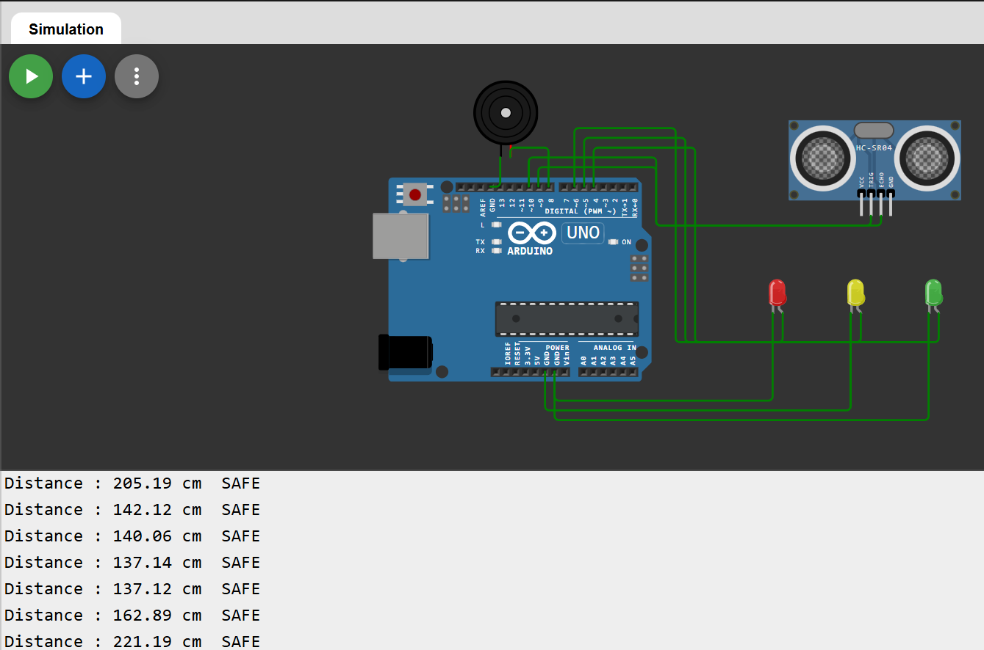

ANS23.
A Smart Street Light system was developed using an LDR and a PIR sensor. The LDR detects ambient light to determine whether it is day or night. During daylight, the LED remains OFF. At night, the PIR sensor enables motion detection. When motion is detected, the LED turns ON at full brightness for 30 seconds. If no motion is detected for 30 seconds, the LED automatically dims to 20% brightness using PWM. All events are logged on the Serial Monitor in the format [HH:MM:SS] EVENT: description.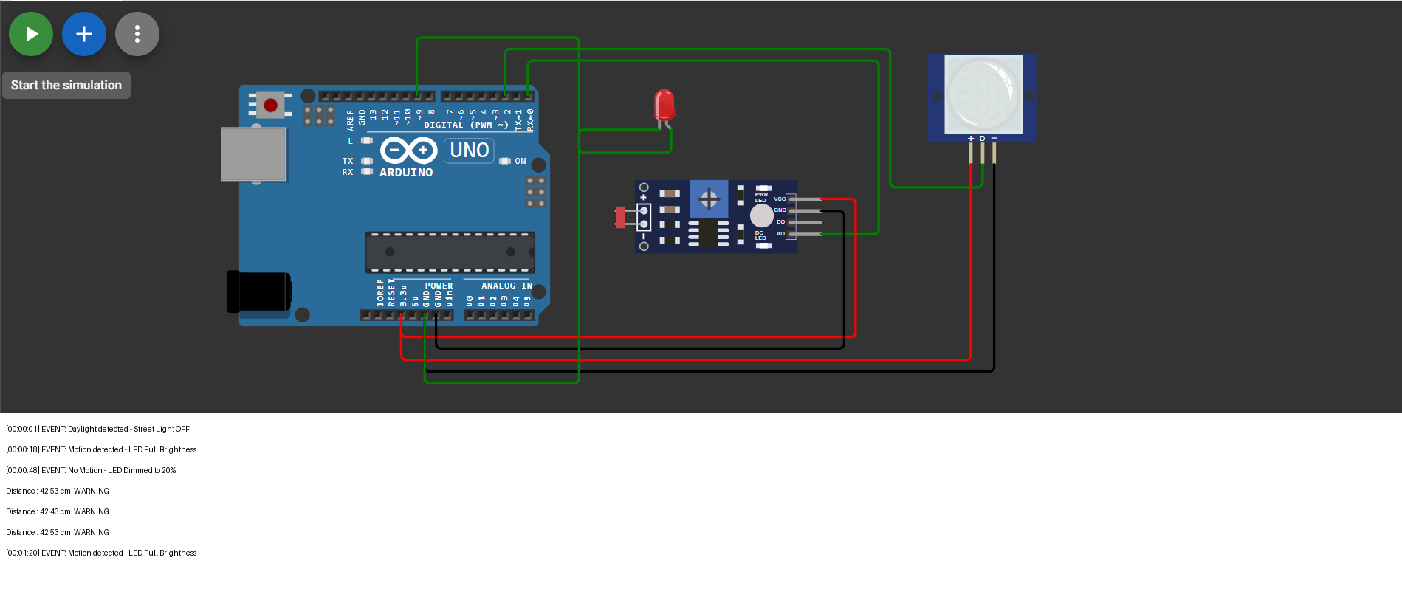

ANS24.
A Multi-Sensor Data Logger was developed using an Arduino UNO with three sensors: DHT22, LDR, and HC-SR04. The system measures temperature, humidity, ambient light level, and distance every 5 seconds. The light intensity is displayed as a percentage along with a status (Bright, Normal, or Dark). All sensor readings are printed in a structured format on the Serial Monitor, and a sample log is stored in week3/data/sensor_log.txt.
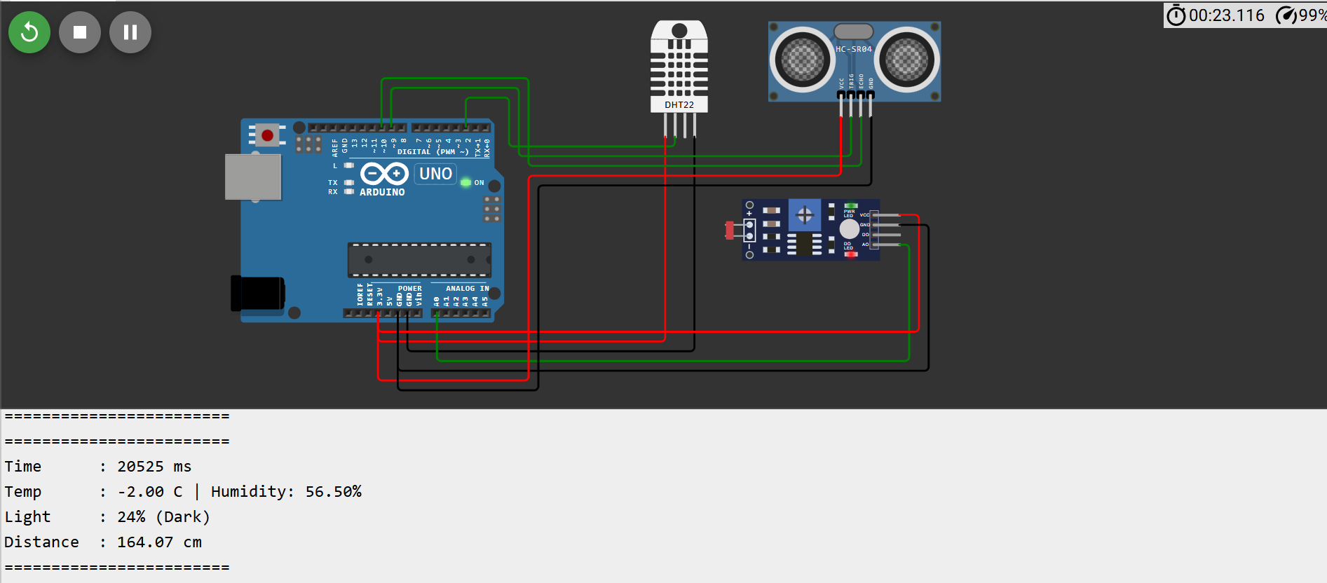

ANS25.
A servo motor control system was developed using an SG90 servo motor, a potentiometer, and a push button. The potentiometer controls the servo angle from 0° to 180°, and the current angle is displayed on the Serial Monitor. When the push button is pressed, the servo performs one complete sweep from 0° to 180° and back to 0°.
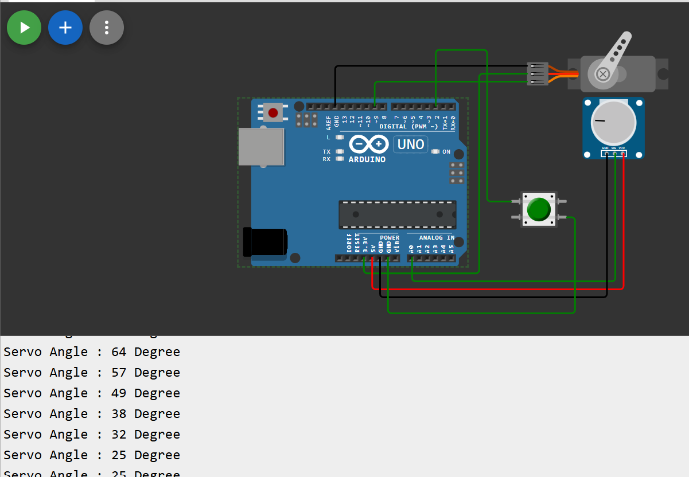

Q26. DC Motor Speed Control with L298N
Control a DC motor through L298N driver: potentiometer sets speed (0–255 PWM), one button changes direction (Forward/Reverse), another button stops/starts the motor. Display Direction, Speed (0–100%), and State on Serial Monitor.

ANS27.
A relay-controlled AC appliance was simulated using an LED. The DHT22 sensor continuously measures the temperature. When the temperature rises above 32°C, the relay (LED) turns ON to represent the AC turning ON. The relay remains ON until the temperature falls below 28°C, implementing hysteresis to prevent frequent switching. A push button provides manual override to toggle the relay state. Every relay state change is logged on the Serial Monitor along with the current temperature.
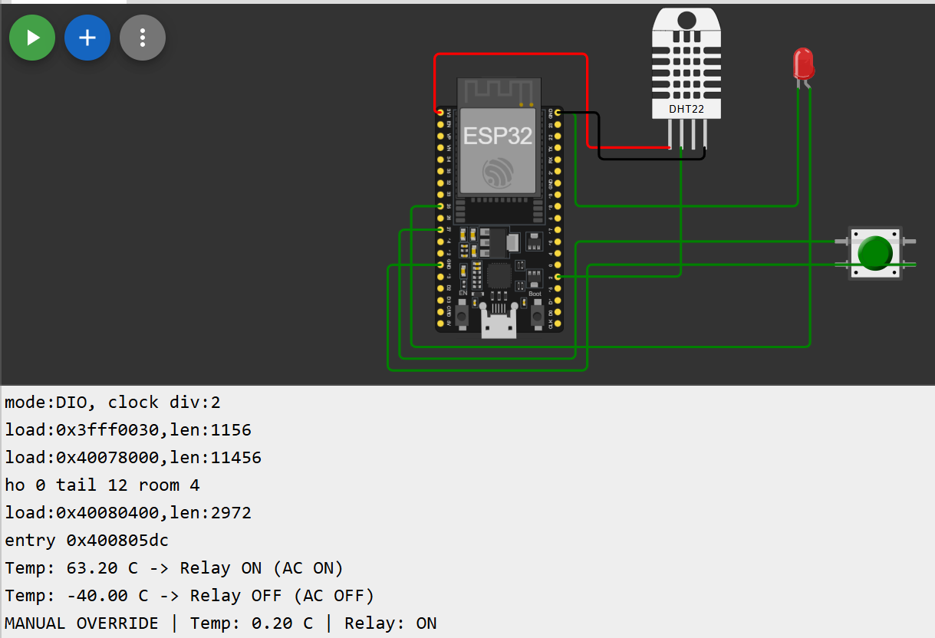

Q28. Keypad + LCD Display
Using a 4x4 membrane keypad and 16x2 LCD, build a password-protected access system: Display 'ENTER PIN:' on LCD, user enters 4-digit PIN, correct PIN (set in code) shows 'ACCESS GRANTED' + Green LED, wrong PIN shows 'ACCESS DENIED' + Red LED + buzzer. After 3 wrong attempts, lock for 10 seconds.

ANS29.
Sensor Calibration
Sensor calibration is the process of adjusting a sensor so that it provides accurate and reliable readings. It involves comparing the sensor's output with known reference values and correcting any errors.
Calibration is important because sensor readings can vary due to manufacturing differences, environmental conditions, or aging.

Calibration is important because it:
- Improves measurement accuracy.
- Increases the reliability of sensor data.
- Reduces measurement errors.
- Helps IoT systems make correct decisions based on sensor values.
For example, an uncalibrated soil moisture sensor may indicate that the soil is wet when it is actually dry, causing incorrect irrigation.

To calibrate an analog soil moisture sensor:
- Place the sensor in completely dry soil (or keep it in air) and note the analog reading.
- Place the sensor in completely wet soil (or immerse the sensing part in water) and note the analog reading.
- Use these two readings as the minimum and maximum values.
- Convert future readings into a percentage using the map() function or an equivalent formula.

Two-Point Calibration Method
The two-point calibration method uses two known reference points:
- Dry Point (0%): Record the sensor value when the soil is completely dry.
- Wet Point (100%): Record the sensor value when the soil is fully wet.
All future sensor readings are converted into a percentage between these two values.
Example:
- Dry reading = 3500
- Wet reading = 1200
A reading between these values can be converted into a moisture percentage using:
moisture = map(sensorValue, 3500, 1200, 0, 100);
This gives a more accurate estimate of the actual soil moisture level.

Conclusion
Sensor calibration improves the accuracy and reliability of IoT systems. The two-point calibration method is a simple and effective way to calibrate an analog soil moisture sensor by using known dry and wet reference values and converting future readings into meaningful percentage values.

ANS30.
I2C (Inter-Integrated Circuit) is a communication protocol used to connect a microcontroller (such as Arduino or ESP32) with multiple sensors and modules using only two communication wires.
It is commonly used in IoT projects because it reduces wiring and allows several devices to communicate on the same bus.

SDA and SCL Lines
I2C uses two communication lines:
- SDA (Serial Data Line): Transfers data between the microcontroller and connected devices.
- SCL (Serial Clock Line): Carries the clock signal that synchronizes data transfer.
Both lines are shared by all I2C devices connected to the bus.

Each I2C device has a unique address (usually 7-bit, sometimes 10-bit).
When the microcontroller wants to communicate with a sensor, it sends that sensor's address first. Only the device with the matching address responds, while all other devices ignore the communication.
This allows multiple sensors to share the same SDA and SCL lines without interfering with each other.

Common IoT Sensors Using I2C
- BMP280 – Temperature and Pressure Sensor
- MPU6050 – Accelerometer and Gyroscope
- BME280 – Temperature, Humidity, and Pressure Sensor
Other common I2C devices include OLED displays (SSD1306), RTC modules (DS3231), and light sensors (BH1750).

Advantages of I2C
- Uses only two wires (SDA and SCL).
- Supports multiple devices on the same communication bus.
- Reduces wiring complexity.
- Widely supported by Arduino, ESP32, and many IoT sensors.

Conclusion
I2C is one of the most commonly used communication protocols in IoT because it allows multiple sensors to communicate with a microcontroller using only two wires. Each device is identified by a unique address, making sensor communication simple, reliable, and efficient.

Module 4: Wireless Communication & IoT Protocols
Marks: 20 | Questions: Q31–Q40 | Type: Connectivity Projects

📡 Communication Technologies Covered
- Bluetooth Classic (HC-05) & BLE (ESP32)
- Wi-Fi (ESP8266 / ESP32)
- MQTT Protocol for IoT messaging
- HTTP REST API calls from microcontroller

Section A: Bluetooth Projects (4 marks each)

Q31. Bluetooth LED Controller (HC-05 + Arduino)
Pair HC-05 with an Android phone using a Bluetooth terminal app. Commands received via Bluetooth:
'R' → Turn Red LED ON
'G' → Turn Green LED ON
'B' → Turn Blue LED ON
'X' → All LEDs OFF
'F' → Flash all LEDs 5 times
Upload code to /week4/bt_led_control/. Include pairing instructions in README (default PIN: 1234 or 0000).

Q32. Bluetooth Sensor Dashboard (ESP32 BLE)
Using ESP32, broadcast DHT11 sensor data over BLE every 3 seconds. A BLE scanning app (nRF Connect or LightBlue) should display: Temperature, Humidity, and a timestamp. Implement GATT characteristics with descriptors. Upload code to /week4/ble_sensor/. Document characteristic UUIDs in README.

Section B: Wi-Fi & Internet (4 marks each)

Q33. Wi-Fi Temperature Monitor (ESP8266/ESP32)
Connect ESP8266 to a Wi-Fi network. Build a simple web server that displays DHT11 data:
- HTML page served at the device's local IP address
- Page shows Temperature, Humidity with auto-refresh every 10 seconds
- Add a button on the web page to toggle an LED on the board
- Display uptime (how long the device has been ON) on the page
Screenshot of the working web page must be uploaded to /week4/wifi_webserver/screenshots/.

Q34. MQTT Sensor Publisher
Use ESP32 to publish DHT11 readings to a free MQTT broker (broker.hivemq.com or test.mosquitto.org):
- Topic: iitjammu/summer26/[yourname]/temperature
- Topic: iitjammu/summer26/[yourname]/humidity
- Publish every 5 seconds in JSON format: {"value": 28.5, "unit": "C", "ts": 1234567890}
- Subscribe to iitjammu/summer26/[yourname]/led_control and toggle LED based on message
Test using MQTT Explorer or MQTT.fx. Submit a screenshot showing messages received.

Appendix A: GitHub Submission Checklist

Before submitting your assignment, verify each item below:

# | Checklist Item | Done? (✓)
1 | GitHub account created with real name and profile photo
2 | Repository named: iot-summer-school-2026 (public)
3 | Folder structure: /week1, /week2, /week3, /week4, /final_project, /theory, /portfolio
4 | README.md at root level with student name, roll number, and project overview
5 | Each assignment subfolder has its own README.md
6 | All .ino files are properly commented (author, date, description at top)
7 | .gitignore file excluding build artifacts, .DS_Store, *.hex, *.elf
8 | Minimum 5 Git commits per module with descriptive commit messages
9 | No passwords or API keys committed to the repository
10 | config.h files added to .gitignore where API keys are used
11 | At least one pull request merged (Q7 collaborative exercise)
12 | Screenshot files uploaded for Wi-Fi dashboard (Q33) and MQTT (Q34)
13 | sample_readings.csv and sensor_log.txt uploaded (Q21, Q24)
14 | Circuit diagram / Tinkercad screenshots uploaded (Q23)
15 | Final project proposal and portfolio markdown files uploaded

Appendix B: Grading Rubric

Assessment Criterion | Excellent (4) | Good (3) | Adequate (2) | Poor (1)
Code Functionality | Works perfectly, handles edge cases | Works with minor issues | Partially working | Does not compile or run
Code Quality | Well-commented, clean, modular | Mostly clean with some comments | Minimal comments, messy | No comments, spaghetti code
GitHub Usage | Excellent commits, branches, PRs | Good commits and structure | Few commits, flat structure | Single commit or private repo
Documentation (README) | Complete, clear, professional | Most sections present | Brief, missing key info | Absent or placeholder
Circuit Correctness | Accurate schematic/diagram | Minor errors in diagram | Conceptually correct only | Absent or incorrect
Innovation / Bonus | All bonus implemented creatively | Some bonus attempted | Basic solution only | Requirements not met

📝 Marks Distribution Summary
- Module 1 – GitHub & Version Control: 20 marks
- Module 2 – Arduino Fundamentals: 20 marks
- Module 3 – Sensors & Actuators: 20 marks
- Module 4 – Wireless Communication: 20 marks
- Module 5 – Advanced Projects: 20 marks
TOTAL: 100 Marks | Bonus marks available up to 10 additional points

